Suprapubic Catheter: My Personal Experience

In October 2011, at the age of 22, I had elective supra-pubic catheter (SPC) surgery under general anaesthetic, on the NHS. Since then, I have overcome various problems associated with my SPC.
Here I offer my account with the intention of assisting those of you facing similar issues, or wondering if a supra-pubic catheter (SPC) is right for you.
*Disclaimer: This is my personal account which in no way represents the experiences of any other person(s). We are all individuals and as such, our bodies react and adapt differently. If you are considering a SPC, I am not suggesting that you should expect to go through what I have. The purpose of this document is to inform, advise and raise awareness of some of the pros and cons of supra-pubic catheters.

So what is a suprapubic catheter?
An indwelling tube (latex or silicone) is inserted into the bladder via an incision in the abdomen. A small balloon is inflated to prevent the catheter from falling out. The external end of the catheter is then attached to a bag which collects urine. Alternatively, you could opt for a Flip-Flo valve allowing you to control when you empty your bladder. This minor procedure, taking no longer than half an hour, is often carried out under general anaesthetic. However, you can request that it be performed under local anaesthetic if you prefer.
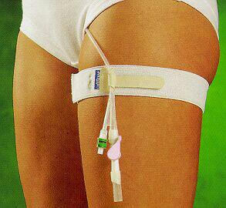
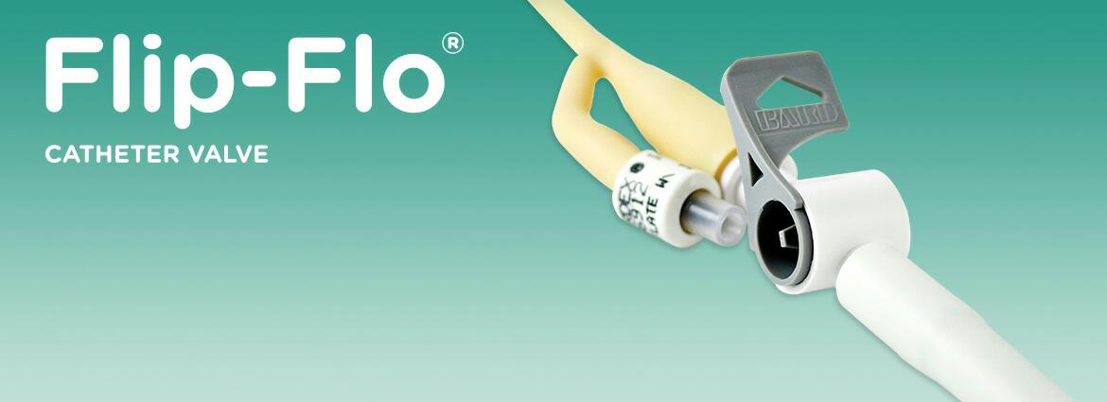
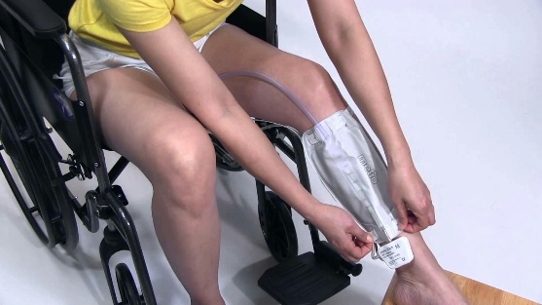
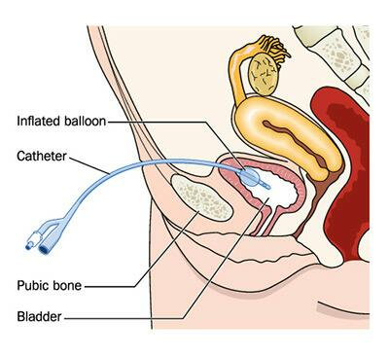

About Me
I have the progressive, muscle-wasting condition Ullrich congenital muscular dystrophy. I am a full-time wheelchair user, unable to weight-bear or transfer independently. I also have a severe scoliosis and joint contractures, making dressing and personal care impossible without assistance. I’ve always had a fully-functioning, healthy bladder and no continence issues whatsoever.
I first learnt about supra-pubic catheters through my own online investigation, after a lifetime spent trialling every toileting method and contraption available. My lifestyle was negatively impacted by my inability to go to the loo independently, particularly when away from home. For many years, I would strictly limit fluid intake and withhold the need to urinate all day, every day.
Finally, with no suggestions or solutions from medical professionals, I requested a urological referral via my GP, and soon my operation was booked. I would at last be able to go to the loo, whenever and wherever, without relying on other people. Despite my concerns regarding the general anaesthetic, I was excited at the prospect of this new lease of life.

Post-operative
I recovered quickly with no complications and left hospital within a few hours. I didn’t want to use a leg bag and so a Flip-Flo valve was attached, which I find much more discreet and practical as well as easy to use. I was in no pain whatsoever.
There was a difficult initial transition period during which I faced urge incontinence and extreme frequency. My bladder recognised the catheter as a foreign object and was attempting to expel it, resulting in overactivity and spasms.
I was at first prescribed Solifenacin Sufficate tablets, a form of Antimuscarinic medication, which caused dry mouth and fatigue. For me, these common side effects were fairly severe; therefore I would advise caution when considering the use of Antimuscarinics. Following this, I moved on to Mirabegron tablets, which suited me far better.
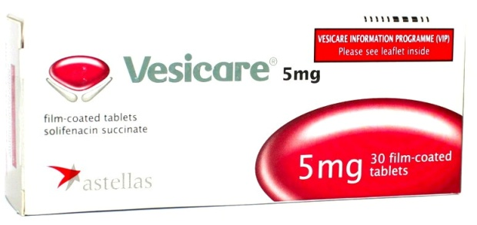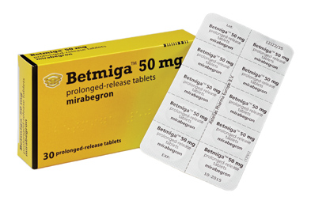
After 12 weeks, my latex catheter was changed for the first time at my local Treatment Centre by a Urology Nurse Specialist. Not knowing what to expect, I was incredibly anxious but thankfully the painless process was over within minutes. There was a fleeting moment of discomfort but nothing more. Whilst I lay on the examination table, Lidocaine gel (local anaesthetic) was applied to the clean site, the internal balloon deflated and the catheter gently removed. A new one was then carefully inserted, the balloon inflated, and a Flip-Flo valve affixed to the external end of the catheter. The insertion of a new catheter must occur swiftly as the hole in the abdomen can heal quickly.
For the next 12-18 months, life was greatly enhanced thanks to my SPC. My catheter changes occurred every 4-8 weeks. I didn’t suffer a single UTI (urinary tract infection) and the only downside was the increased frequency. Prior to the SPC, I had been emptying my bladder only 2-3 times daily, whereas I was now needing to do this at least every hour.

Problems
During a routine appointment with the Urology Nurse, my latex catheter wouldn’t budge. Long-term, indwelling catheters can ‘stick’ somewhat resulting in discomfort and awkward removal. Some people twist them occasionally to try and avoid this, though it can cause slight leakage from the site.
Nevertheless, this particular catheter was completely immovable. The indwelling tip was overly encrusted with calcification, and therefore too large to fit through the incision in my abdomen.
I have full sensation and a fair tolerance for pain. But believe me; I am not being overdramatic in stating the experience of trying to remove that catheter without pain-relief was intolerable.
Panicking, the nurse admitted defeat and sent me to the Alexandra Hospital in Redditch. Neither she nor I had any idea what they could or would do.
Stressed and exasperated, I waited in A&E for over 3 hours before being told by a doctor that all they could do was give the stubborn catheter “a damn good tug”, again without any pain-relief. I couldn’t endure anymore, and so was forced to return 2 weeks later as an in-patient for the catheter to be removed and replaced, under general anaesthetic.
Frustratingly, this was not a one-off occurrence. Due to repeated encrustation of the catheter tip, it has been necessary for me to undergo several subsequent surgeries and general anaesthetics, in order to remove and replace my SPC. Throughout this time, I saw District Nurses, a Urology Nurse Specialist and two Urology Consultants. I continually questioned why this was happening and what could be done to prevent the encrustation.

Necessary surgeries resulting from problematic catheter change:
- October 2012
- June or July 2014
- 27th March 2015
- 1st July 2016
- 9th December 2016

Before each routine appointment, I would feel physically sick with anxiety, not knowing if my catheter would get stuck, thereby necessitating yet another surgical procedure. My lung function is acutely impaired by my condition (Ullrich congenital muscular dystrophy) and general anaesthesia for me is incredibly risky. I couldn’t continue like this.

In September 2017, dissatisfied at the level of care received at Kidderminster Hospital and Treatment Centre, I requested to be transferred to the Urology team at Worcestershire Royal Hospital. I am happy to report that I now see two Urology Nurse Specialists who offer a thorough, caring and conscientious service. They are informative, supportive and respectful of my disability and my troublesome experiences with encrustation.
According to their advice and supervision, I now use a size 14Fr open tipped silicone catheter with a smaller 5ml balloon to avoid bladder irritation. The balloon is inflated with an antimicrobial solution (Farco-fill Protect) rather than sterile water. This helps to eradicate calcification and encrustation. My SPC is successfully changed every 4-5 weeks with the aid of Entonox (Nitrous Oxide) to ease any pain and discomfort.

My complete list of supplies (Those marked in red are the products I now use)

* Yushin ‘Supra-Flo’ all silicone two way open tip Foley catheter with ‘Unibal’ integral 5ml balloon – size 14 Fr
* Prosys® catheter valve (for silicone catheters)
* Farco-fil Protect: http://www.clinimed.co.uk/Urology-Continence-Care/Incontinence-Products/Farco-Fill-Protect.aspx
* Biocath Aquamatic hydrogel coated pre-filled catheter female 18Ch D226818 10ml balloon (Bard Ltd) – latex
(I began with a size 16Ch latex catheter, but over the years I have also used sizes 14Ch, 18Ch and 20Ch)
* Bard Flip-Flo® catheter valve (for latex catheters)
* Rusch Brilliant AquaFlate All-Silicone 10ml balloon 16ch (female)
* Hydro-caine gel 6ml syringe
* Antibacterial wipes
* Gamgee tissue blue label (gauze to use as a dressing when needed)
* Mepore® Tape
* OpSite Flexigrid dressing 15cm x 20cm
* Uro-Tainer Twin Solutio R citric acid 6% catheter maintenance solution
* Uro-Tainer Twin SUBY G citric acid 3.23% catheter maintenance solution
* VESIcare 5mg solifenacin succinate tablets
* Betmiga 50mg Mirabegron tablets

If you have any questions, please contact me:
Facebook: @lifeontheslowlane
Twitter: @claimesuk
Website: https://lifeontheslowlane.co.uk

